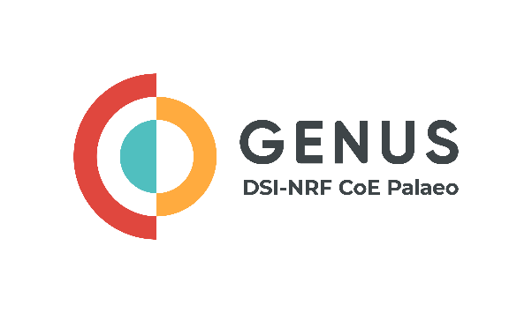

Progress Report for

GENUS Research Grant
We Dig Fossil Grant
Equipment Grant
Salary Grant

Title:
Surname:
First names:
Primary email:
Primary cell number:
NRF Rating:
ORCID number (https://orcid.org/signin):
University:
Department:
Do you receive another source of funding outside of the CoE? List below the funding source you received (include the name of funder, amount, and year when funding ends):
List the grant(s) you received:
- GENUS Research
- We Dig Fossils
- Equipment Grant
- Salary Grant
Only one application is required, even if the grantee received multiple grants.

Title of project

A short abstract of the research project

Summary of highlights stemming from your research

Academic citizenship

- Leadership highlights – include promotions, awards, certificates, or academic achievements

- Describe any initiatives untaken to promote the implementation of active inclusiveness in the palaeoscience community

- Training - This may include courses, lab training, field training, etc

- Committees – provide the name on the committees you sit on and your position (e.g. member or chair)

- Editorial team – provide the name of the journal and your position on the editorial team

- Data storage – is your data open access? Explain how your data has led to usage, and dissemination

Science engagement
Briefly, detail and science communication or science engagement that you developed and implemented

Publications and Conferences
Report on all publications, whether supported by GENUS/CoE Palaeo or through other funding platforms.

List peer-reviewed publications, books, or book chapters  Example: Nkosi E, Dlamini M, Jacobs J. 2021. Large mammal biodiversity and distribution in the African Miocene. Journal of Vertebrate Paleontology 50(2): 10- 20. | Peer-reviewed article, book, or book chapter | Supported by the CoE  (Yes / No) | Was the CoE acknowledged  (Yes / No)
List of conference presentations and posters  Example: Nkosi E, Dlamini M, Jacobs J. 2021. Large mammal biodiversity and distribution in the African Miocene. 95th Annual Meeting of the Vertebrate Society, New Orleans, Louisiana, USA. 17-21 May. | Conference presentation or poster | Supported by the CoE Palaeo (Yes / No) | Was the CoE acknowledged?  (Yes / No)

Primary collaborators
Title | Initials | Last name | Institution | Department | Country | Role of Collaboration

Summary of expenditure
Grant Amount given R
Item | Amount
TOTAL | R
Leftover for 2023 | R

Checklist
- Completed APR
- Up-to-date Curriculum Vitae
- Include all your postgraduate students and postdoctoral fellows with starting dates and end dates (or expected end dates)
- Updated NRF profile (https://nrfsubmission.nrf.ac.za/nrfmkii/)
- Send required documents to info.genus@wits.ac.za

Signature of Applicant Date

